* Web Communication Fundamentals
* Understanding REST Vs SOAP
* Message Exchange Formats – XML & JSON
* Performing Callouts to External Services
  + HTTP Request & HTTP Response

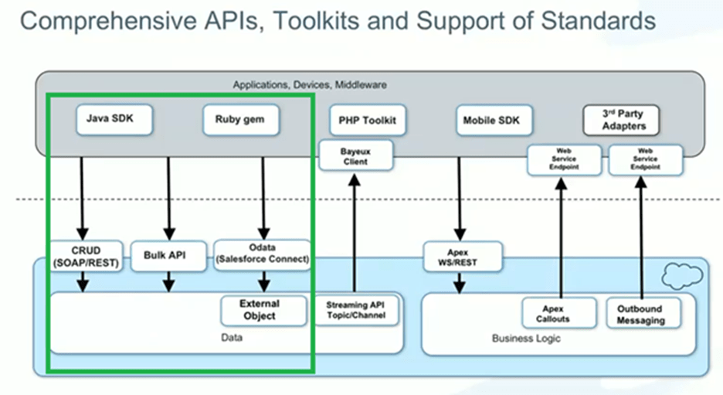

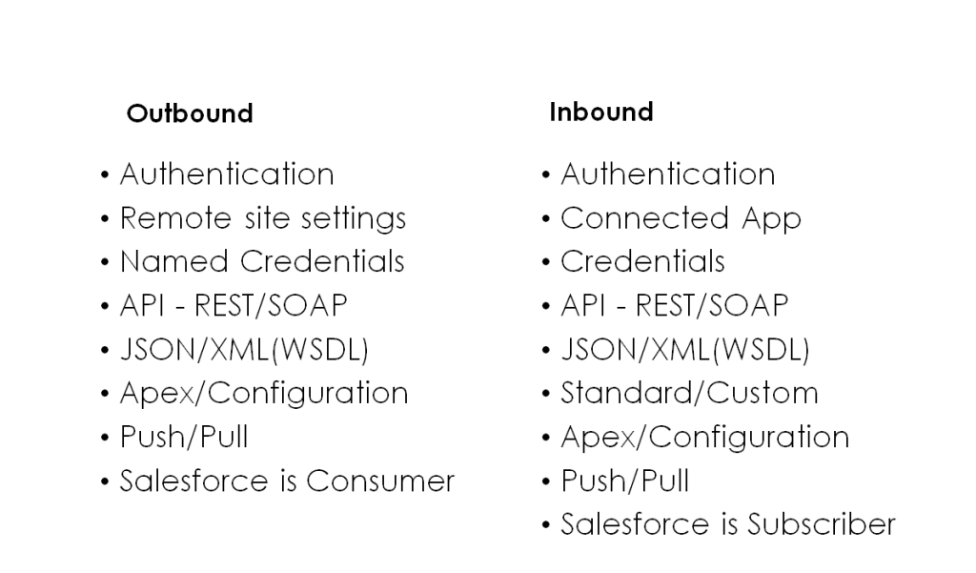

# Authentication

* User Authentication
  + Username / password
  + Password never expires for API user
  + Profiles based restrictions
  + API only user
  + Limits on number of failed attempts
* Authorization – OAuth
* Data Security
  + How is access to data regulated?
* Network Authentication
  + Login hours and IP ranges
  + Org-wide trusted IP Address List
  + Security Token for login via API or client outside white-listed IP range
* Make sure the profile of the integration user meets the needs.

# Authentication

* Apex ignores security
* Session Timeouts
* Transport Security
  + SSL provides secure transport over HTTPs
* Outbound
  + Two-way SSL
  + Port Restrictions
    - Port 80, 443, 1024-66535
  + Remote Site Settings
    - Sites which can be invoked from Salesforce

# API

* Application Programming Interface
* Set of functions and procedures allowing the creation of applications that access the features or data of an OS, application, or other service.
* Set of specifications, such as Hypertext Transfer Protocol (HTTP) request messages, along with a definition of the structure of response messages, usually in an Extensible Markup Language (XML) or JavaScript Object Notation (JSON) format
* For example, Twitter’s REST API allows developers to access core Twitter data and the Search API provides methods for developers to interact with Twitter Search and trends data.

# Basics of JSON

* JSON Stand for “JavaScript Object Notation”.
* Recommended for devices with low processing power or slow internet
* It is language Independent representation of objects
* Text based, human readable data exchange format
* Parsers available in many languages
* JSON can be transmitted over http / https

{

  “FirstName” : “Apex”,

  “LastName” : “Hours”,

}

# JSON to Apex

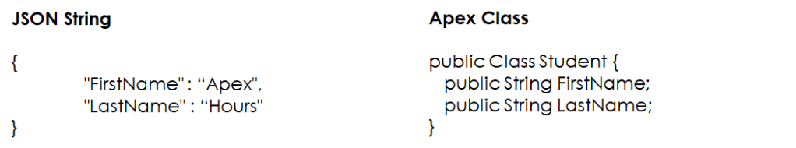

**JSON to Apex Deserialization**

String jsonString = ‘{“FirstName” : “Apex”,”LastName” : “Hours”}’;

Student st = (Student) System.JSON.deserialize( jsonString , Student.class);

# Basics of XML

* XML stands for eXtensible Markup Language like HTML
* XML tags are not predefined. You need to define your customized tags.
* Well, the structured format is easy to read and write from programs.

<student>

  <firstname>Apex</firstname>

  <lastname>Hours</lastname>

</student>

# JSON Vs XML

|  |  |
| --- | --- |
| **JSON** | **XML** |
| JavaScript Object Notation has a type like String, number, Object, Boolean | Extensible markup language is type less, and should be string |
| It is a way of representing objects | It is a markup language and uses tag structure to represent data items |
| Retrieving value is easy | Retrieving value is difficult |
| It does not provide any support for namespaces. | It supports namespaces. |
| It is less secured | It is more secure than JSON |
| Guidelines: Key – Enclosed in double Quotes (String) Value – Can be any datatype {} – Object [] – Array, – Separates data element within Object | Guidelines: Element – <lastname>hours</lastname> Element Definition: <xs:element name=”lastname” type=”xs:string”/> Attribute – <lastname lang=”EN”>Smith</lastname> Attribute Definition – <xs:attribute name=”lang” type=”xs:string”/> |

# Which API Do I Use?

|  |  |  |  |
| --- | --- | --- | --- |
| **API Name** | **Protocol** | **Data Format** | **Communication** |
| REST API | REST | JSON, XML | Synchronous |
| SOAP API | SOAP (WSDL) | XML | Synchronous |
| Chatter REST API | REST | JSON, XML | Synchronous (photos are processed asynchronously) |
| Analytics REST API | REST | JSON, XML | Synchronous |
| Bulk API | REST | CSV, JSON, XML | Asynchronous |
| Metadata API | SOAP (WSDL) | XML | Asynchronous |
| Streaming API | Bayeux | JSON | Asynchronous (stream of data) |
| Apex REST API | REST | JSON, XML, Custom | Synchronous |
| Apex SOAP API | SOAP (WSDL) | XML | Synchronous |

# 

# REST API

* Representational State Transfer is a style of software architecture for distributed hypermedia systems.
* REST API has a lightweight request and response framework
* Simple, easy to use and powerful web service based on RESTful principles.
* Expose functionality via REST resources and HTTP methods.
* (CRUD) records, search or query your data, retrieve object metadata, and access information about limits in your org.
* REST API supports both XML and JSON.
* Mobile and Web apps
* Rest resource is referenced using URI, abstraction of information, access using HTTP methods

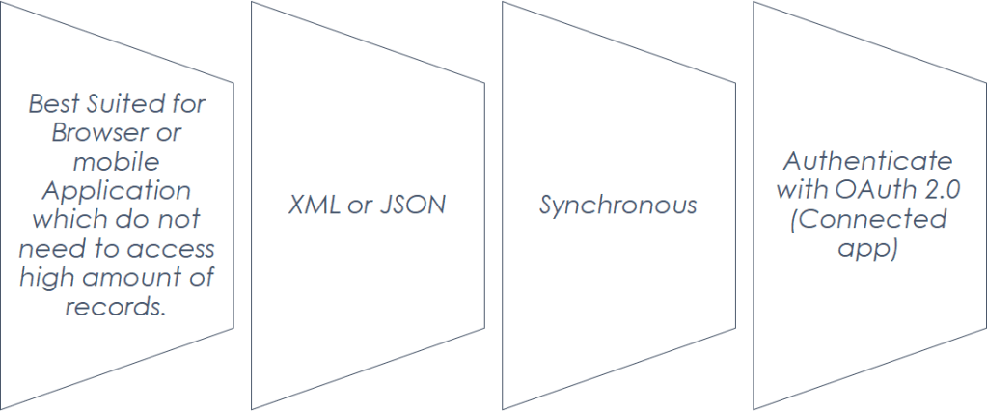

REST API

# HTTP Methods

|  |  |  |
| --- | --- | --- |
| **Method** | **Action** | **Details** |
| HEAD |  | Retrieve resource metadata |
| GET / @HttpGet | Read | Reads or retrieves records |
| POST / @HttpPost | Create | Creates records |
| PATCH / @HttpPatch | Update | Update fields in existing records |
| PUT / @HttpPut | Upsert | Update existing or create records |
| DELETE / @HttpDelete | Delete | Deletes records |